Directions: The goal of the following problems is to help challenge and deepen your understanding of the current topic. Don’t assume that you will know how to answer each and every question. You will work with at least two other students in the class to try and find solutions and write arguments for each of the following questions. Be sure that you question your classmates’ reasoning. If you don’t understand how they are getting something you should ASK THEM TO EXPLAIN! Being able to defend your reasoning is important and so you are actually helping them by asking them to explain.

Challenge Questions
- Determine the equation of the line tangent to the curve at .

- Determine all values of x where has tangent lines parallel to the line .

- Determine the equation of the line tangent to the curve at .

- Determine all values of x where has tangent lines perpendicular to the line .

- Find conditions on a, b, c, & d so that the graph of the polynomial has…
- exactly two horizontal tangents.
- exactly one horizontal tangent.
- no horizontal tangents.

- Find k if the curve is tangent to the line .

- Find all values of a such that the curves and intersect at right angles.

- The segment of any tangent line to the graph of that is cut off by the coordinate axes is bisected by the point of tangency.

- Show this works for when .

- Show this works for when .

- Suppose that the function f is differentiable everywhere and that .
- Express a formula for in terms of x and derivatives of f.

- Express a formula for in terms of x and derivatives of f.

- For, conjecture of formula for .

- Consider the polynomial functions , , and , where represent real numbers.
- Find , , and .

- If n represents the degree of the polynomial, then what is the -st derivative of any polynomial? Why?

- Newton’s Law of Universal Gravitation states that the magnitude F of the force exerted by a point with mass M on a point with mass m is where G is a constant and r is the distance between the bodies. Assuming that the points are moving, find a formula for the instantaneous rate of change of F with respect to r.

- Show that if exists for each x in , then is continuous on .

- The following graph depicts the position of two racers.
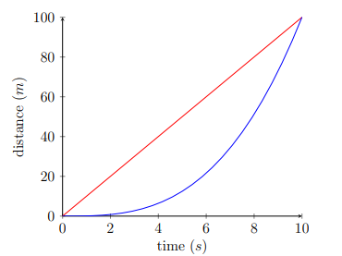
- Which racer has a faster average speed? When was each racer running faster than the other (approximately)? Which racer was running fastest at the end of the race?

- On a separate plot from this picture, sketch the graphs of the velocities of these racers.

- Suppose that the distance (from the starting point) of the red racer is given by the function and the distance of the blue racer is given by . Suppose that & . Use this new information (and your knowledge of derivatives) to check whether your answers in parts (a) and (b) were accurate.

